FAntasy ball

# Overview

Fantasy Ball is a brick breaker type game. The player can move a paddle side to side to avoid the ball from falling into the pit while trying to break the bricks in the level and maximize the score. There are multiple variants of Brick breaker games, namely some of them are Dx-Ball, Breakout, Brick Breaker, Grove Flowers, etc. Each of these have variances in terms of the abilities of the paddle, the ball, the bricks themselves and scoring mechanics but the core loop in all these remain the same i.e. breaking bricks, avoiding the ball to fall below the paddle ( avoiding death ) and maximizing score.

For this DFS project, I plan to create a Forest Fantasy themed brick breaker game with a limited number(for now the plan is at least 3) of levels that can be painted using a chroma key, this might be changed to some PCG algorithm if they don’t feel sufficient enough. For the game to feel fun and juicy, the plan is to adding is multiple different types of power ups for the ball and the paddle with varying brick types.

Menus will be navigated with arrow keys and the enter key / Mouse controls. Paddle is controlled via mouse movement and powerups will use mouse button mashing.

|  |  |
| --- | --- |
| Controls | |
| Mouse Horizontal Movement | Paddle movement |
| Mouse Left Click | Paddle Power1 |
| Mouse Right Click | Paddle Power2 |

# Reference Images

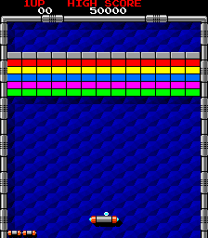

[1] Arkanoid

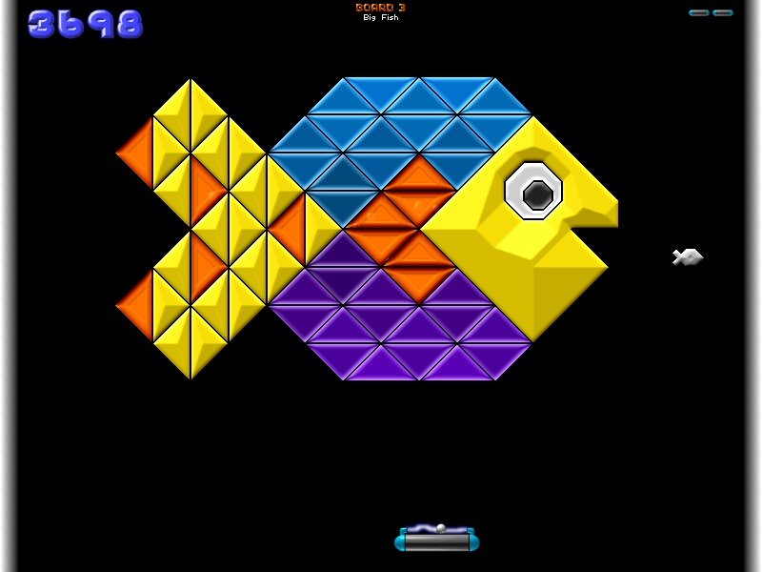

[2] DX-Ball Series

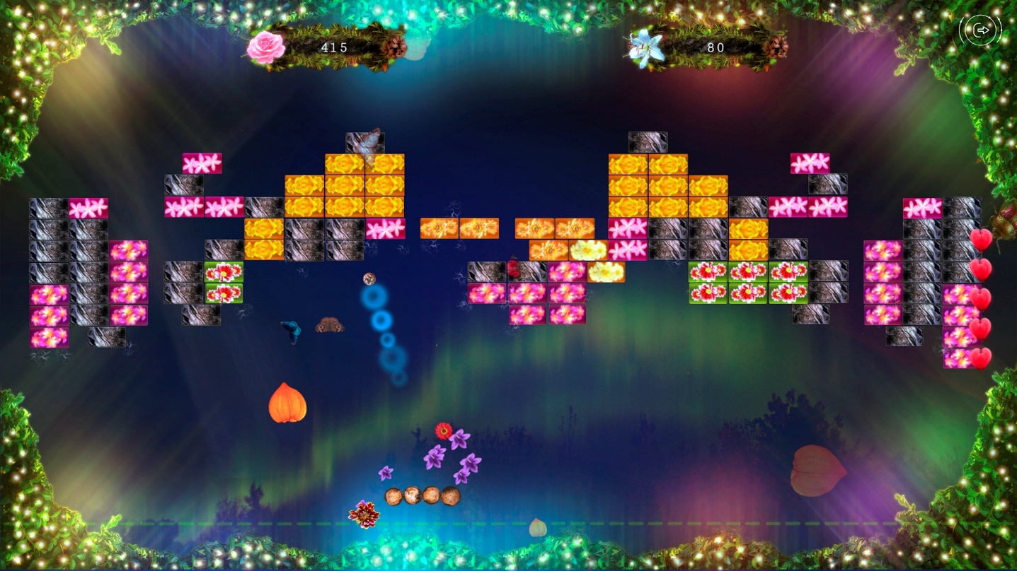

[3] Grove Flowers

# JUICE/PowerUp Ideas (not sure about these)

1. Paddle Based Ideas –
   1. Extend Paddle – can extend paddle to max of 2.5x the base paddle. Each time you collect it you can extend by 0.5x the base paddle.
   2. Shrink Paddle - can shrink paddle to min of 0.5x the base paddle. Each time you collect it you can extend by 0.5x the base paddle.
   3. Shooting Paddle
   4. Grab Ball
   5. Lock Paddle in place for 10 seconds.
   6. Airstrike from the top.
2. Ball Based Ideas –
   1. Multiply Balls by 2x – can have max of 16 balls.
   2. Increase Ball Speed by 2x.
   3. Decrease Ball Speed for a time of 10 seconds.
   4. Increase Ball Size.
   5. Decrease Ball Size.
   6. Thu-Brick – Destroy All brick in the incoming path for next 10 seconds.
3. Gameplay Based Ideas –
   1. Elemental Tile & Ball types – electricity, water, fire, earth, etc.
   2. Elemental Weapons for Paddle –
      1. Lighting Bullet – Pierces through the current column.
      2. Fire Bullet – Can Burn earth type tile.
      3. Water Bullet – can destroy only fire and lighting type , so on…
   3. Elemental combination (goes in conjunction with any of the above) –
      1. Fire + Earth = lava .. but to achieve this not more than 3 base elements would be best.
   4. Kill Paddle
   5. Extra life
   6. 2x/3x Score multiplier for next 5,10,15 seconds.
   7. Go to Next Level.
   8. Multiply certain type of tile.
   9. Invert Paddle and Pit – paddle and pit are inverted and go to the top.

# Milestones

## Milestone 1 06/15/2020

First deliverable with limited game play. A Menu System with Main Menu and in game HUD with a controllable paddle with a test level with different brick types and some power ups.

* Player controls Paddle with Mouse Movement.
* Player can use the Menu using Mouse or Keyboard.
* Non-Persistent High Score system where players can enter their name for up to maximum of 10 top scores.
* Main menu with some sub menus like settings, controls (only for display) and high score menu.
* Data driven gameplay components like -
  + tiles types
  + tile assets
  + paddle asset
  + Configurable Settings like –
    - Base Paddle Size
    - Max Paddle Size
    - Min Paddle Size
  + And more.
* Some basic ball and paddle powerups.
* Simpler Physics system for collisions between ball and paddle and ball and the tiles. (the current system lacks performance).
* Stress testing Physics system for performance.
* Setup Initial Test Level

Milestone 2  
06/29/2020

Adding in particle effects, levels and powerups.

* Adding in a 2D-Particle system.
* Integrating Particle system with tiles.
* Screen-Shake effects.
* Finalizing 3 levels / level generation technique.
* Scoring mechanics based on how the tile is destroyed.
* In game HUD to display score level number and current lives.
* Finalizing powerups.

### Stretch goals (Unsure how it would feel in the game)

* Integrating Particle system with the ball.
* Environmental Hazards.
* PCG for level generation (I would like there to be patterns rather than random worms).

Milestone 3  
07/13/2020

Adding in Audio, Saving the data, polish & refinement.

* Saving High Score Data.
* Refining Menus.
* Game over screen displaying your score and displaying all the high scores where you can enter name if you beat a high score and a return to main menu button.
* RNG based Power Drop on tile breaks.
* Adding in audio effects for different tiles breaking and background audio.
* Audio for the Menus.

### Stretch Goals / mILEstone 2 dependent goals

* Adding in More levels

Final Deliverable  
07/21/2020

Final polish, bug fixing and some more UI & levels.

* Pause Menu
* Tutorials Menu

### Stretch Goals / mILEstone 2 dependent goals

* Additional Levels if PCG is not used for infinite level generation.

# REFERENCE LINKS

[1] [Arkanoid](https://en.wikipedia.org/wiki/Arkanoid)

[2] [Super DX Ball.html](https://classic.blitwise.com/superdxb.html)

[3] [Grove Flowers](https://wenrexa.itch.io/grove-flowers-arkanoid)

[4] [Rival Ball](https://en.wikipedia.org/wiki/Rival_Ball)

[5] [Super Glove Ball](https://en.wikipedia.org/wiki/Super_Glove_Ball)

[6] [Breakout Clone Games](https://www.ranker.com/list/the-best-breakout-clone-games-of-all-time/kyle-townsend)

[7] [Deconstructing Breakout-Style Games](https://www.gamasutra.com/view/feature/1630/breaking_down_breakout_system_and_.php?print=1)